**Establishing an experimental control in 3D simulated environment to measure and characterize human learning using regression analysis**

Honours Thesis in Cognitive Science

Steven Szu Han Chen

214036784

F/W 2017

Supervised by:

Thilo Womelsdorf

**Abstract**

The present thesis seeks to understand the process of context-based categorical learning and how attention is allocated during it. We developed a general-purpose experimental platform for running attention-based learning tasks. Our setup included an eye-tracker to record participant’s gazes while doing the task. The task involved determining the relevant and irrelevant objects based on a given context. For data processing, a pipeline was created to classify eye gazes into sequences of fixation and a replayer was built to map the fixation to various objects and regions in the environment. By building various regression models, we found that participants tend to look at the target objects more than the distractor objects. Furthermore, there are less fixations on the objects as the learning curve increases.

**1. Introduction**

When interacting with the environment, humans naturally shift their eyes towards salient events to select information. When they visually sample the surrounding area, their eyes tend to move to specific locations of the visual field and this oculomotor action is known as saccades. In contrast, fixation is when they rest their eyes on these locations for a few hundred milliseconds (Wilming, Betz, Kietzmann, Konig., 2011). By controlling these sequences of saccades and fixation, humans can control what information reaches their visual cortex. This alternation of eye movements can help us understand how humans learn and attend to the environment.

In this paper, we are mainly interested in eye movements, particularly fixations. It is known that in problem solving and learning tasks, fixations can easily reveal important characteristics to human cognition and attention (Salvucci, 1999). To do so, we created a natural 3D environment using a novel hardware and software system that is designed to be customizable and extensible. It can interface with different hardware such as an electrocorticography (ECoG) monitoring device and it allows experimenters to freely create different types of learning rules for their tasks. By using an eye-tracker that can record eye gazes at a fine grained resolution of 300 hertz, we study how much time people need to process various stimuli and how often they need to look at them during our learning task. We created a context-based categorical learning task where subjects are required to determine the relevant stimuli. Categorical learning in eye-tracking studies have shown that fixation counts and durations to irrelevant stimuli do not differ from those to relevant stimuli until several trials after category rules have been learned (Blair, Watson, & Meier, 2009; Rehder & Hoffman, 2005). The main hypothesis of this study is that there will be roughly equal number of fixations on both relevant and irrelevant stimuli during learning and more fixations on the relevant stimuli after learning has occurred. However, the duration of fixation on the relevant object should decrease after learning (Chen et al., 2012).

**2. Materials**

**2.1. Hardware Setup**

The game is setup with various integrated hardware components including a Tobii TX300 Eye-tracker attached to an external display monitor, a joystick, a custom-built Neurarduino, consisting of an Arduino Mega with various input/output ports, that connects all hardware components for timing purposes, a pair of photodiodes, and a host MacBook Pro laptop (see Fig. 1).

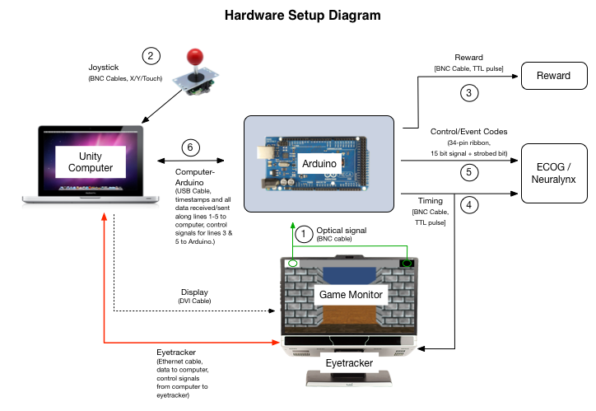

**Fig. 1.** The hardware setup includes many components and is easily extendable via the Arduino. In this experiment, we do not need the ECOG/Neuralynx and Reward as they are intended for monkeys and other types of human subjects.

2.1.1 *Tobii Eye-tracker*

The Tobii Eyetracker allows head free and non-invasive eye tracking at 300 hertz and it comes with a software development toolkit (SDK) that provides the API for using the eye tracker functionalities such as calibration and illumination. The eye tracker records several important information including eye positions, timestamp, validity code and pupil diameter.

2.1.2. *Joystick*

The joystick is used for navigating throughout the game. Our setup allows different types of joystick can be connected via USB or BNC Cables. The one we used outputs two coordinates; X and Y.

2.1.3. Photodiodes

The photodiodes are clipped on to the top two corners of the experiment monitor for timing analysis. They pick up the two flashing black and white panels which are switching alternatively multiple times per frame.

**2.2. Software Setup**

The software infrastructure includes a Python app that is the essence to glues all the hardware components together. It interfaces with the eye tracker, collects data and displays the subject's eye calibration and positions. Moreover, it exchanges messages with the game client. The app consumes all the eye-tracker related data and manages for further operations such as sending the data to the client or saving the data to text files.

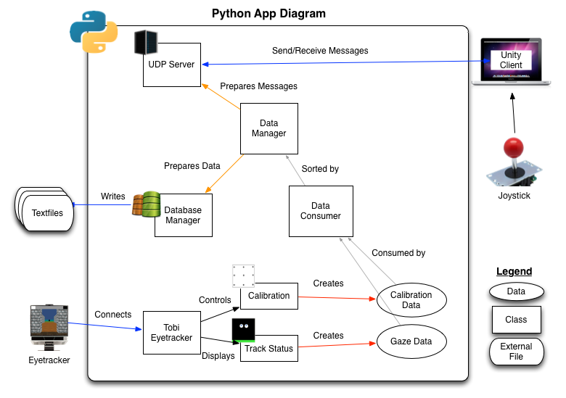

Fig. 2. The internal infrastructure of the Python app. The rectangular boxes are the classes and objects in the app. The ovals are the data that is being produced and parsed. The squashed rectangular are external files created by the app. Other hardware components that also communicate with the app are shown.

**3. Methods**

**3.1. Participants**

Eleven subjects with normal or corrected-to-normal vision were recruited to participate in this experiment. Eight of them are York University students and the remaining three are young adults who are in the workforce. One subject’s data was removed due to data corruption.

**3.2. Environment, Context, and Stimuli**

The game has three important aspects that composes the learning task. The simulated environment is the arena that the player navigates through. The context floors indicate the ruleset of the trial. The stimuli are the objects that exist in the arena which encompasses the possible combination of category or dimension features.

3.2.1*. The Simulated Environment*

The main scene of the game is a large square arena enclosed by walls. Each of the four walls has a distinct landmark placed beyond it to aid with navigation. In this experiment, there are two main objects that are placed randomly on the floor where one is the rewarded target and the other one the unrewarded distractor. There can be other kinds of objects but they are never-relevant distractors.

3.2.2. *Context Floors*

The context is the floor of the arena which can take on X possible states. The floor indicates which particular object feature is the relevant and which particular value of the feature is rewarded. For example, for a given trial, an icy floor might indicate that objects with thick arms would be rewarded. During each block of trials, each trial would come from one of two contexts, so the main task is to learn which feature and which of its values are associated with each context.

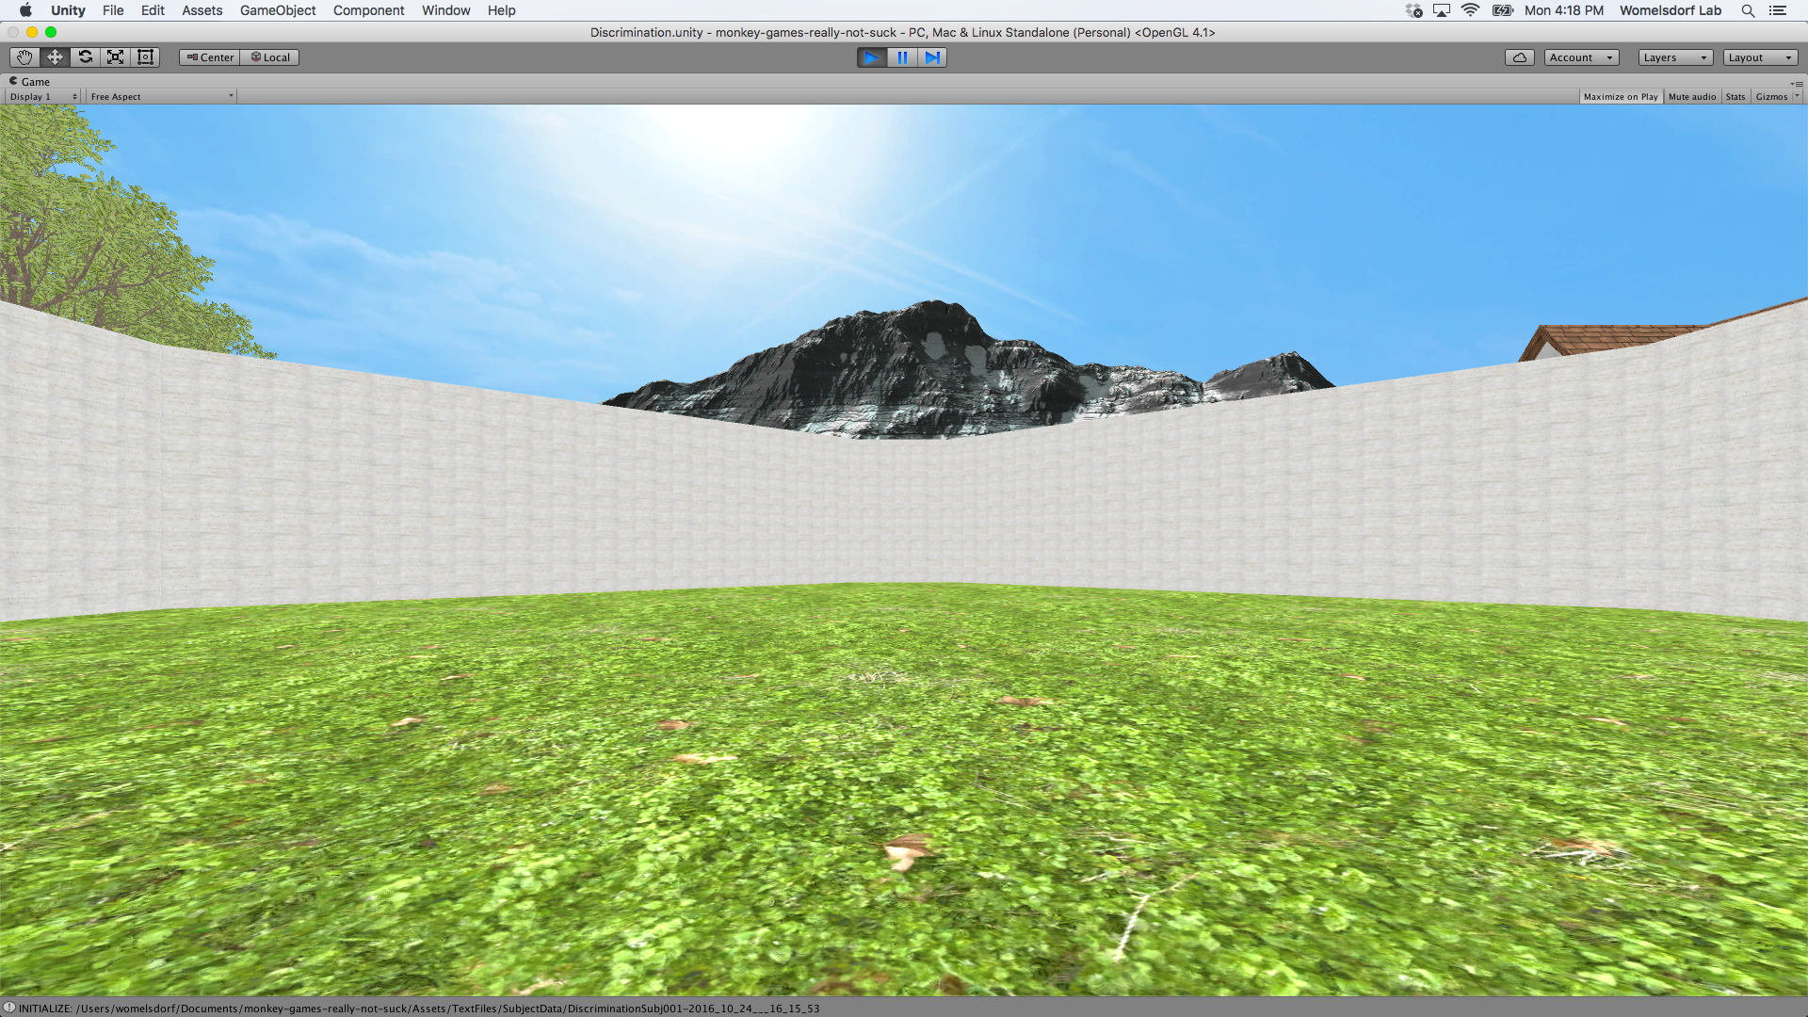 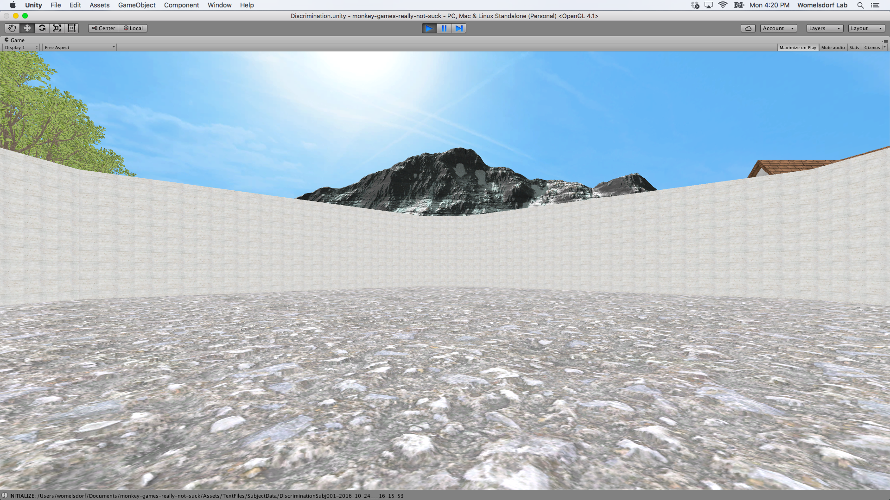 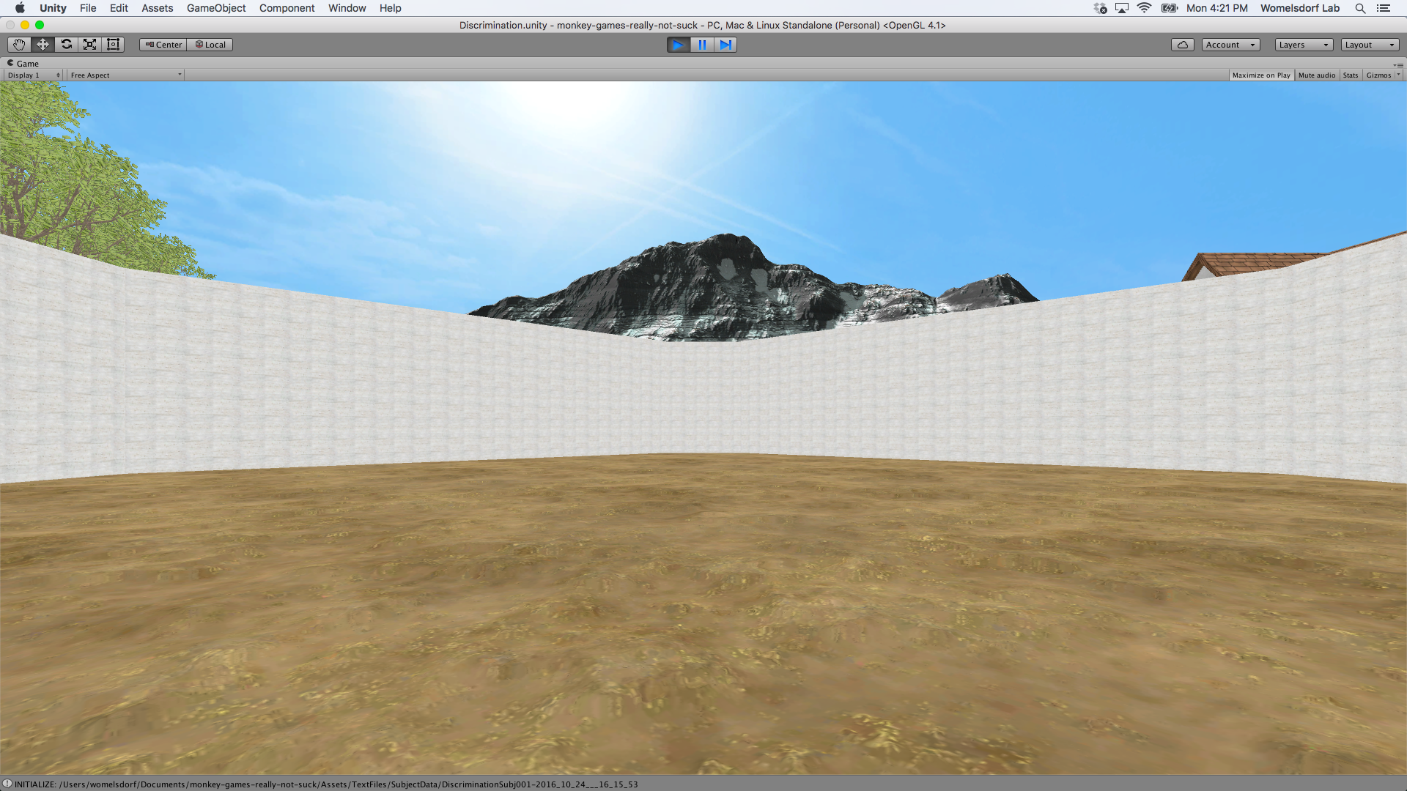

**Fig. 3.** Examples of context floors

3.2.3. *Quaddles as stimuli*

The objects that appear in the arena is called the Quaddles (See Fig. 4). Quaddles are defined by four features (body shape, body color, body texture and arm orientation) each with two possible values (e.g. the body shape can be pyramidal or oblong).

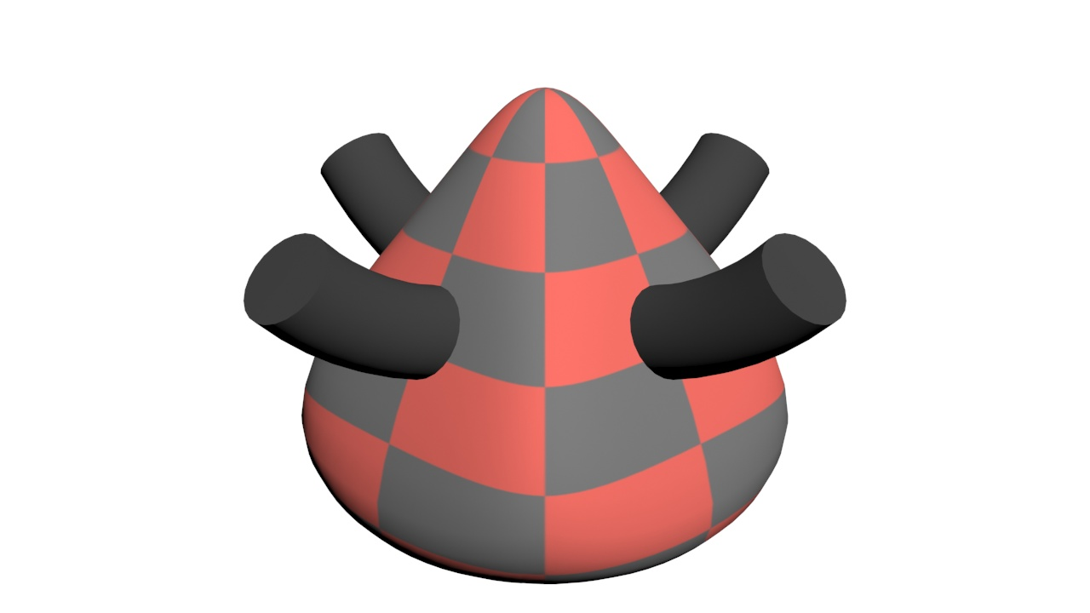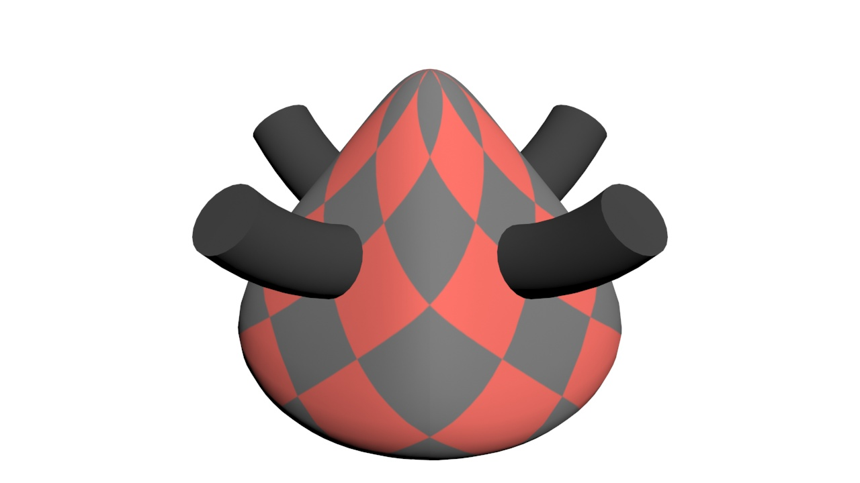

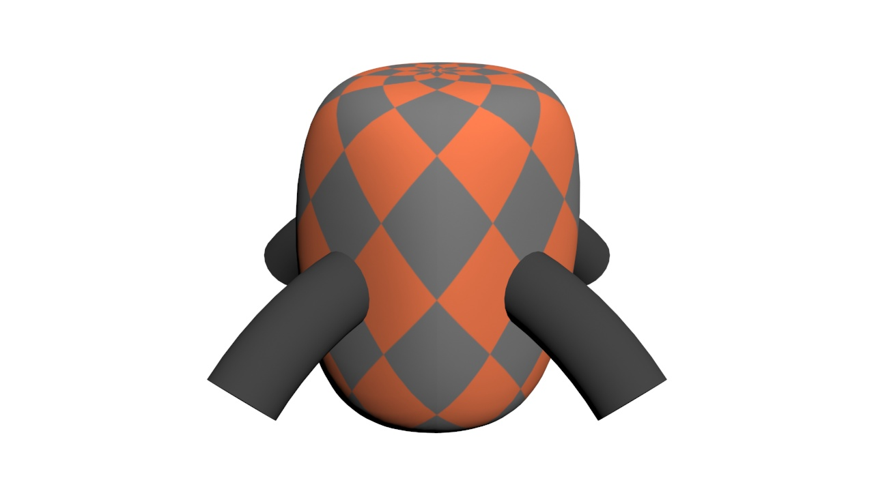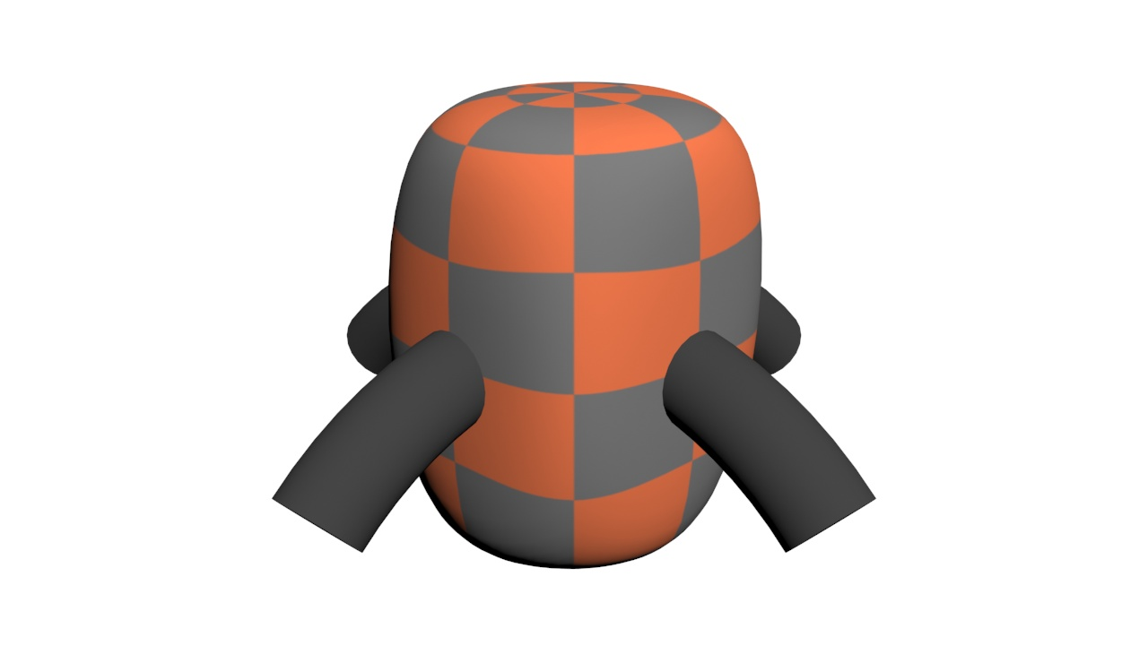

**Fig. 4.** Example of four different Quaddles. From Left to Right.

Top Row: Pyramidal/Red/Checkered/Up and Pyramidal/Red/Diamond/Up

Bottom Row: Oblong/Orange/Diamond/Down and Oblong/Orange/Checkered/Down

**3.3. Procedure**

Subjects were asked to sit on the a 50 to 60 centimeters away from the monitor at eye level with their hands placed on the joystick.

*3.3.1. Calibration*

Each participant was first fitted and calibrated to the Tobii TX300 eye tracker*.* The calibration procedure is to estimate the geometry of a participant’s eyes and to ensure accurate gaze point computation. The eye tracker measures the characteristics of a user’s eyes and use them together with an internal anatomical 3D eye model. During the calibration, the participant is asked to look at nine calibration dots on the screen. Images of the eyes are analyzed during this interval. With the TX300, the user does not have to keep the head completely still during calibration as long as their eyes are focused on the moving calibration dots. If the quality of the calibration result is insufficient, the participant is asked to redo the calibration until the offsets are minimal and they are able to opening the fixation keyhole without any problem.

*3.3.2. Tutorial*

After the calibration, sequences of textual instructions are shown on the center of the screen. The instructions are to welcome the participants and briefly explain the general mechanism of the actual task. In the tutorial, participants are introduced how to use their eyes to interact with the fixation doors and use the joystick to navigate their player. Audio feedback is given for most of the actions such as opening fixation doors, picking up or exchanging objects, and bringing objects to the reward door. The tutorial includes 18 mock trials that teach participants the basics of navigation and the task structure.

*3.3.3. Main Task*

The main experiment is composed of a series of context-based trials. Depending on the context, particular stimuli feature and its feature value is relevant. To initiate a trial and open the door to the square arena, the subjects need to fixate on the fixation keyhole in the small itertrial room for 200 milliseconds or longer. In the arena, two Quaddles are placed randomly on the floor and the player can only pick up one at a time by navigating close to it. After the player selects the chosen object, the player can bring it to any reward door with a white asterisk shape on it. The door will open and the asterisk will turn into a green "+" if it is the correct object or a red "x" if it is the incorrect object. Shortly, the player is teleported to the intertrial room again and the entire process is repeated. The main objective is to learn to determine the relevant feature and feature value, and associate the value to one of the two contexts. In each block, the contexts are different. This context-depended feature selection is learned through a sequence of blocks. Blocks effectively train the player to generalize the relevant feature irrespective of the exemplar object. At the end of each block, we expose the player to trials in which context one and two are randomly interleaved. Each block has minimum of eighteen trials and terminates when accuracy over the last twelve trials is 85% or higher, or when a maximum of 100 trials is reached.

**4. Results**

The raw gaze data and the game data from all the trials are computed to obtain important features that we are interested in. These include the classification of gaze data into fixation and saccades. These classifications are then feed into the replayer and it produces a table of the mapping of the fixation and the objects in the scene. This mapping gives us different categories of fixation and we are only interested in target and distractor fixations. Moreover, two types of learning accuracy were created from the trial outcomes. They are the smooth learning accuracy and the EM learning accuracy. Together, the fixation categories and only the EM learning accuracy are used in the regression models. We created three different models to evaluate the effect of each fixation categories and to determine which ones contributed the most to the variance of the independent variable (EM accuracy).

4.1. *Temporal Accuracy*

To ensure the data collection is temporally accurate, UNIX timestamps are attached to every packet of data transferred among the system. By using a low-latency and loss-tolerating communication protocols called User Datagram Protocol (UDP), we can mitigate any loss of data packet transfer. In our system, the Python app keeps track of all the UDP sent/received packets and eye-tracker raw gazes, and the game client built with Unity keeps track of all the game, trial, block and task design related information.

**4.2. Gaze processing**

Parsing the data to enable analyses with fixation is split into four separate steps. These steps include collecting and saving different types of data, classifying the raw gaze data, determining which objects the fixation intersect, and creating the fixation categories for the final regression analyses.

4.2.1. *Collecting raw gazes during runtime*

There are some components of the area such as the floors and walls that are spatially static during the entire experiment. However other components including the player camera, target/distractor objects, doors and rocks are dynamically changing their positions and sizes on each recorded frame. Note that these refer to positions, rotations, and sizes within the virtual 3D scene created by the Unity 3D Engine. The actual appearance of the screen on any frame is a combination of the current position and rotation of the player camera, and the current positions, rotations, and scales of every object in the scene.

A separate data file is created recording the trial-specific data, including the identity of the target and distractor on each trial, the time it took the participant to pick up their chosen object and then to take it to the reward door, and the final trial outcome (binary)

In the experiment, three relevant types of data files are created: the eye tracker’s raw gaze data recorded at 300 hertz, the frame data from Unity 3D recorded at 60 hertz, and the trial data.

4.2.2. *Classifying the raw gaze data*

To classify the raw gaze data, we used the algorithm recommended from by Larsson, Nyström, & Stridh (2013, 2014). In this adaptive algorithm, artifacts including blinks, off-screen gaze and periods where the eye tracker records invalid data are all identified and classified in both eyes. We replace the periods of invalid gaze data that are only one or two samples long by using cubic interpolation over a 100 ms period. Any remaining periods of gaze data that had artifacts were removed. The gaze data from both eyes is then averaged, and smoothed using Savitzky-Golay filtering (Orfanidis, 1998).

Five different types of gaze classifications were produced by the algorithm by combining pieces of gaze information. These classification types are saccade, post-saccadic oscillation, fixation, smooth pursuit, or unclassifiable. The gaze information is recorded by the eye tracker which contains an estimate of the distance of participants’ eyes from the eye tracker, and the intersection of their gaze with the screen for each gaze sample. By joining both pieces of information, we translated screen positions from pixel coordinates to degrees of visual angle and feed them to the algorithm to obtain the desired classifications. Using the eye tracker timestamps recorded in both the gaze data and frame data files, each of these periods is matched to a specific set of frames. For the purpose of this study, everything is ignored except fixation.

4.2.3. *Determining fixation objects*

The next step is to map the fixations to differently labeled stimuli in the environment. The entire participant session is replayed in Unity 3D from the frame data trials, setting the positions, rotations and sizes of each object on each frame to their values as recorded in the original session. During each frame where a fixation occurred, the current target of that fixation is determined by finding the mean position of gaze during the fixation, and the object that is currently found onscreen at those pixel coordinates. This is accomplished using raycasting, a standard tool in video game engines that allows the determination of the first object in the virtual scene intersected by a vector (the ray) sent out from any point (cast) in the scene.

4.2.4. *Labeling Fixations to Regions and Stimuli*

For each fixation in the experiment, its modal object (the object that appeared at the fixation’s center point for the largest number of frames) is determined. In each case where this object is one of the Quaddles, we identify if this was the target or distractor on the current trial. We can then quantify the number and duration of fixations to targets and distractors during each trial of the experiment. For the purpose of this study, we are only concerned with the fixations that land on targets or distractors before the player has picked any object up.

**4.3. Learning Curves**

The main interest of this paper is to study the learning curves or the proportion of correct responses in each block for every subject. To do so, we have to convert the binary discrete outcomes of every trial into a continuous valued learning accuracy. We do this in two ways: first, averaging across a backwards-looking sliding window of 5 trials, and second, using a forward-looking EM algorithm outlined in the work of Smith et al. (2004). Their approach is implemented by using a state-space model and binomial EM algorithm to estimate a learning curve that characterizes the probability of a correct response as a function of trial number (Smith et al. 2004). In contrast, this EM accuracy is a forward looking algorithm which makes the curve smoother than the smooth learning curve.

Only eight of eleven subjects were used to do the analysis because three of them were unable to converge for the EM algorithm. Each block is truncated to 18 trials and we average each trial across all the blocks for each individual subject. The smooth accuracy for all subjects is calculated by averaging each individual subject’s smooth accuracy. For the smooth accuracy curve, the error bars are calculated by finding the standard deviation of each trial and dividing it by the square root of the sample size (N = 8). For the EM curve, the upper and lower confidence interval is plotted.

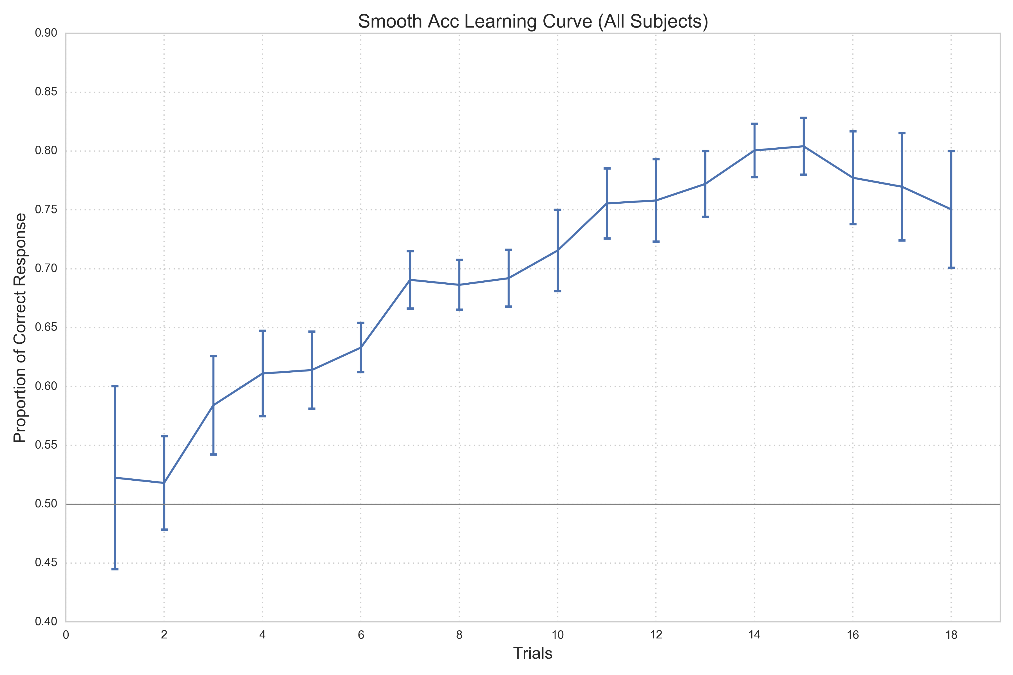

**Fig.2.** Smooth learning accuracy is calculated with a backward-looking window of size 5. The first trial is a bit higher than the second trial for the smooth learning accuracy because it is backward-looking and there is not enough data to look back for. This explains the drop from trial 1 to 2.

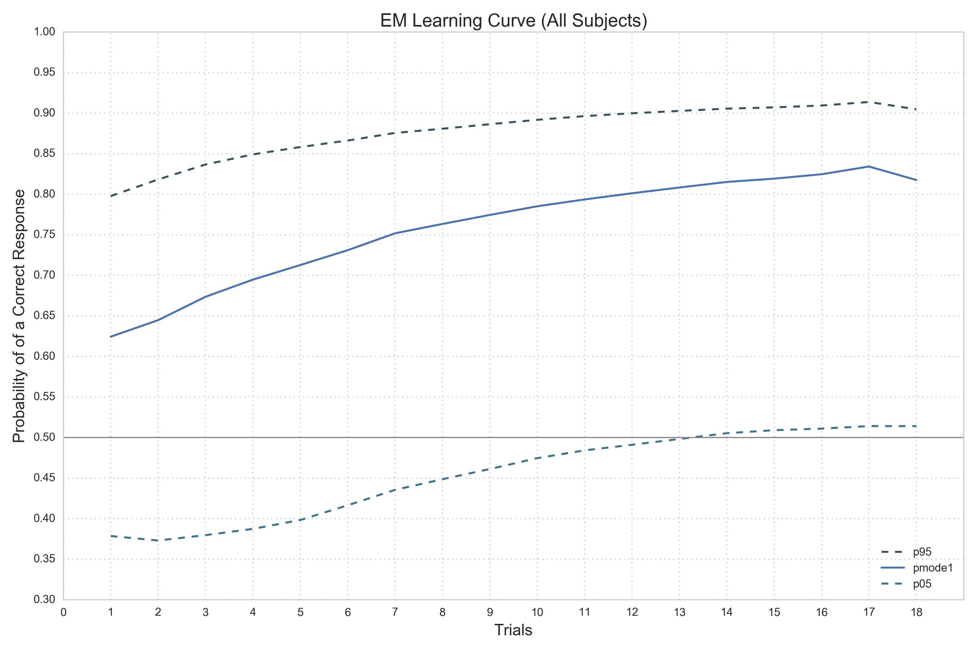

**Fig.3.** The drop in trial 18 can be explained by the nature of a forward looking algorithm since there isn’t any more data to look forward to at the last trial. The dotted curves indicate the upper and lower 95% confidence intervals. The estimation of each individual trial can lie anywhere between this interval and the solid curve is the mode of the estimation.

**4.4. Main Analysis**

Different matrices of predictors were as the training data for the regression model. We created three models in total and generated regression summary for all of them. The goal here is to find the most contributive predictor for learning accuracy

The correlation matrix shows that all the four predictors negatively correlate with the EM accuracy (Fig. 8) and the strongest one being the distractor count and the least strong being the target duration. This result upholds the assumption that the number of fixations on the target or distractor objects decreases as learning accuracy increases or when a task is learned.

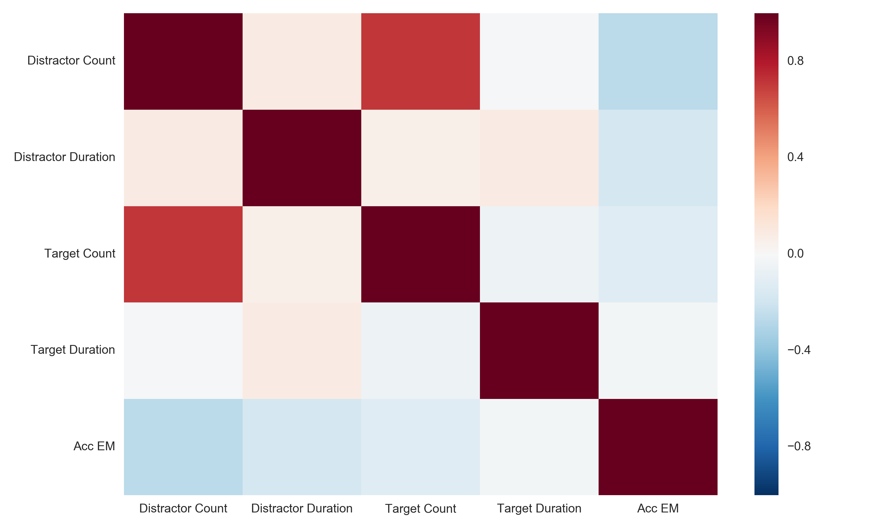

**Fig. 4.** Heat map of the correlation matrix

4.4.1. *First Model – Block’s Trial as Predictor*

We first looked at the simplest model which is only using the trial number as the predictor.

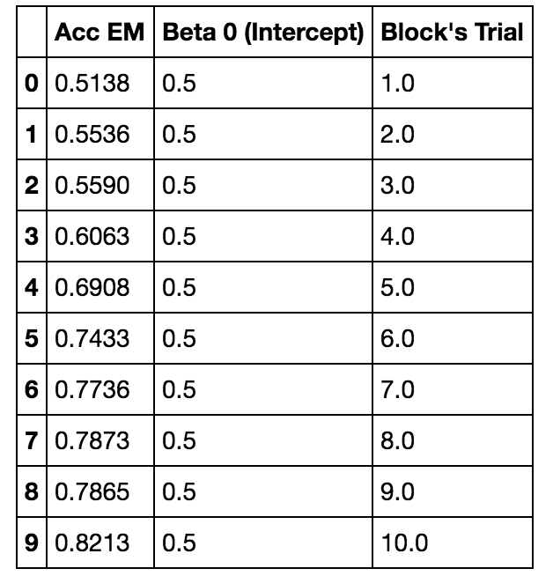

**Table 2.** A table of the first ten rows where the first column (Acc EM) of the table is the dependent variable and the remaining two columns are used to create our model. The intercept is a constant of 0.5 because if all the predictors were 0, the chance of getting a correct response is 50%. Block’s trial is the only predictor here.

As shown in Fig.4, the ordinary least squared regression results for the model with only block’s trial as the independent variable are: slope coefficient = 0.0024, p-value < 0.05, and the R-squared = 0.036 or 3%. It can be interpreted that block’s trial barely affects the EM accuracy and that only 3% of the response variable variation is explained by our model.

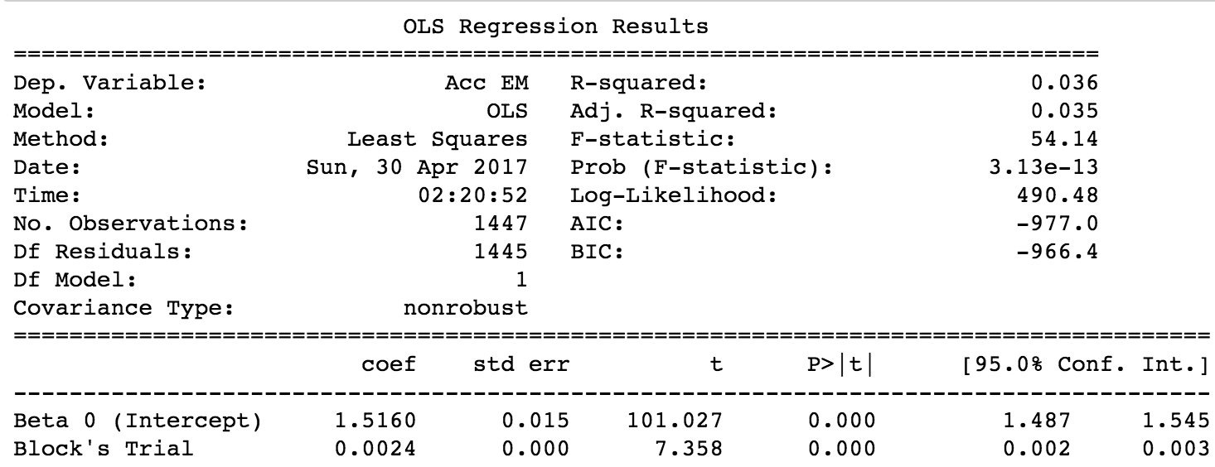

**Fig. 5.** Regression results of one predictor

4.4.2. *Second Model – Target and Distractor Counts as Predictors*

The second model that we used included two fixation features; the mean number for distractor and target for everyone trial. To have the maximum possible number of observations, we replaced the observations where either the target or distractor count was NAN to 0. This is a logical thing to do because if there isn’t a fixation on the target or distractor in a given trial, that means there were 0 fixations in whatever category.

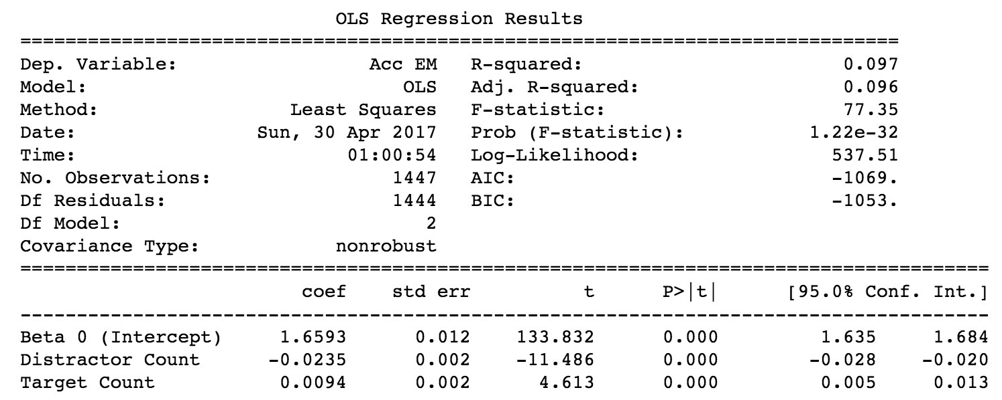

**Fig. 6.** Regression results of two predictors

Our regression model with target and distractor counts confirmed that as you keep learning the task or improving your proportion of correct responses, the less you look at the distractor and the more you look like the target. Furthermore, based on the coefficients of the target count, it also implies that target count is not necessary increasing as Acc EM increases. The key takeaway from this model is that distractor is negatively correlated to the independent variable. The r-squared of this model is 9.7% which improved slightly from the previous model.

4.4.3. *Third Model – Target and Distractor Counts/Duration as Predictors*

The last model that we created include four predictors which are the counts and durations of fixation on target and distractor. This model is the best model so far (See Fig. 6) where the R-squared is 10% but it is important to remember that typically regression models with more independent variables have higher R-squared. However, our third model also confirms that distractor-related features are negatively correlated to the Acc EM. This means that the participants overall tend to look less at the distractor and spend less time looking at them. Again, the fixation on targets increases slightly but also made small impact on the Acc EM. The only abnormal result of this model is that the p-value is very high for target duration which will be discussed below.

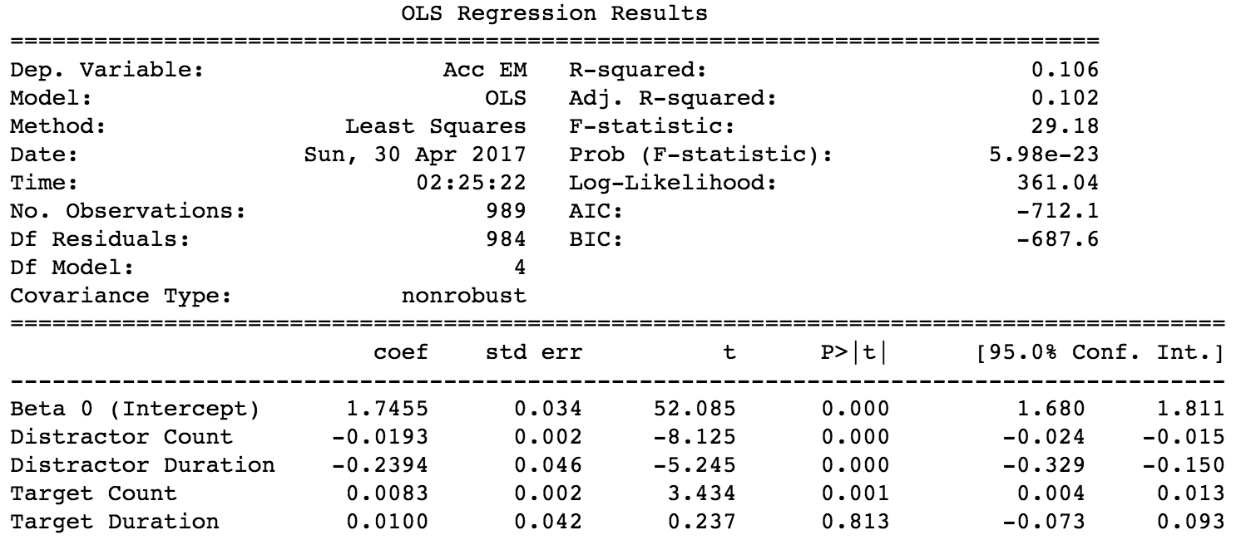

**Fig. 7.** Regression results of four predictors

**5. Discussion**

In the regression analyses, we mostly examined the slope coefficients, p-values, or R-squared produced by each model but we acknowledge that is not the entire picture. As claimed by many of the eye-tracking studies, this thesis shows that there is a biased attention towards relevant information and away from irrelevant information during our learning. As the learning accuracy improves, the mean count and duration of target fixation increases. In contrast, fixation on distractors is negatively correlated with the learning accuracy. This demonstrates that the target to distractor fixation ratio is higher as EM accuracy increases.

Although our study shows there is a significant effect of the independent variables on the dependent variable, except target duration (due to high value of p) in the four predictor regression model, there are multiple caveats about this experiment that one should be aware of. One important caveat is that the learning criteria for this task is not precisely defined. This makes it hard to interpret at what trial do the subjects learn and it also makes it difficult to identify the interval of trials for pre learning and post learning. It should also be noted that the eye-tracking studies referenced in this paper and even other studies in the current literature are mostly based on traditional static-view tasks where our novel experiment is a dynamic viewing one. In this case, we are also missing information about the nature of fixation itself and any occurrence of smooth pursuit that can occur frequently in a dynamic viewing environment. Furthermore, it should be noted that calibration offsets can come from many factors such as the user not focusing on the point, being distracted, lighting issues or the eye tracker is not setup properly. Sometimes this can be a latent problem where every few gaze samples are corrupted. A natural way to deal with missing data or corrupted data is to replace the values with appropriate interpolation which is not included in this study.

Due to the shortage of time, it was difficult to obtain a solid sample size of 20 – 30 which would be more adequate for the regression analyses because as the sample size increases, the variance or noise decreases. Moreover, some subjects were exposed to different sets of objects, which may influence the stimulus discrimination. But this may or may not affect the duration of the fixation. Lastly, not all subjects completed the same length of blocks hence some individuals might contribute more when calculating the average of the independent and dependent variables.

**6*.* Future Direction**

This thesis can be improved in many ways. First as mentioned, one should first identify the learning criteria or points for each context in each block. The current study does not split the trials by context which may influence significantly the learning accuracy computed. More over by determining the learning criteria, we can find the period of pre and post learning such that we can compare the ratio of target to distractor fixations in both periods. The hypothesis here is that the ratio of target to distractor fixations should be the same in pre-learning period and the ratio should increase in post-learning. Next is to improve the regression model and to include other fixation predictors such as fixation on context floor so we can determine how often and how long subjects tend to look at the context. Also we can generate whether or not a trial is in pre-learning or post-learning stage and try to build a machine learning model that can predict where the trial belongs to. This would be an easier model to build due to the discrete nature of the independent variable.

Lastly, our platform is highly customizable, expendable and portable which allows future tasks and it would be interesting to change the rules of the task to probabilistic rewarding. By improving our hardware setup and the calibration process, we can also get animal subject like monkeys to play this game and compare their behaviours to human behaviours.

**7. Acknowledgement**

This work is supported and guided by Marcus Watson, Ben Vologh and Thilo Womelsdorf. I would like to acknowledge them for their aid in data collection, analysis, literature review and for their general advice and suggestions about my direction in the research. Thank you.

**Bibliography**

Blair, M. R., Watson, M. R., Walshe, R. C., & Maj, F. (2009). Extremely selective attention: Eye-tracking studies of the dynamic allocation of attention to stimulus features in categorization.*Journal of Experimental Psychology: Learning, Memory, and Cognition, 35*(5), 1196-1206. doi:http://dx.doi.org/10.1037/a0016272

Blair, M. R., Watson, M. R., & Meier, K. M. (2009). Errors, efficiency , and the interplay between attention and category learning. *Cognition*, *112*(2), 330–336. <http://doi.org/10.1016/j.cognition.2009.04.008>

Chen, L., Meier, K. M., Blair, M. R., Watson, M. R., & Wood, M. J. (2013). Temporal characteristics of overt attentional behavior during category learning, 244–256. http://doi.org/10.3758/s13414-012-0395-8

Larsson, L., Nystroum, M., & Stridh, M. (2014). Discrimination of fixations and smooth pursuit movements in high-speed eye-tracking data. 2014 36th Annual International Conference of the IEEE Engineering in Medicine and Biology Society. doi:10.1109/embc.2014.6944450

Larsson, L., Nystrom, M., & Stridh, M. (2013). Detection of Saccades and Postsaccadic Oscillations in the Presence of Smooth Pursuit. IEEE Transactions on Biomedical Engineering, 60(9), 2484-2493. doi:10.1109/tbme.2013.2258918

Orfanidis, S. J. (1998). Introduction to signal processing. Place of publication not identified: Prentice Hall.

Rehder, B., & Hoffman, A. B. (2005). Eyetracking and selective attention in category learning q, *51*, 1–41. http://doi.org/10.1016/j.cogpsych.2004.11.001

Salvucci, D. D. (1999). Mapping Eye movements to Cognitive Processes. In Proceedings of the Twentieth Annual Conference of the Cognitive Science Society, 923–928.

Smith, A. C., Frank, L. M., Wirth, S., Yanike, M., Hu, D., Kubota, Y., … Brown, E. N. (2004). Dynamic Analysis of Learning in Behavioral Experiments. *The Journal of Neuroscience*, *24*(2), 447 LP-461. Retrieved from <http://www.jneurosci.org/content/24/2/447.abstract>

Wilming N, Betz T, Kietzmann TC, K. P. (2011). Measures and Limits of Models of Fixation Selection. *Current Science*, *101*(11), 1435–1439. http://doi.org/10.1371/Citation

**Appendix**

|  |  |  |  |  |  |
| --- | --- | --- | --- | --- | --- |
|  | **Distractor**  **Count** | **Distractor**  **Duration** | **Target**  **Count** | **Target**  **Duration** | **Acc EM** |
| **Distractor**  **Count** | **1.000000** | 0.083011 | 0.717959 | -0.014165 | - 0.268059 |
| **Distractor**  **Duration** | 0.0034816963100198751 | **1.000000** | 0.061774 | 0.082083 | - 0.179650 |
| **Target**  **Count** | 1.5421093293162181e-196 | 0.029814324318487333 | **1.000000** | - 0.052973 | - 0.121390 |
| **Target**  **Duration** | 0.6186777424327059 | 0.0038660261328538597 | 0.062527406376950326 | **1.000000** | - 0.031189 |
| **Acc EM** | 8.4339734136674586e-22 | 1.9664905467105042e-10 | 1.8611053694586777e-05 | 0.27303570254187587 | **1.000000** |

**Table A.** Correlation Matrix where the upper right triangle is the correlation and the lower left triangle is the p-values.

*Note:*

Each individual EM Curves can be found on the online in the Thesis Jupyter Notebook hosted on the platforms below.

* The Python and Matlab source code to conduct the analysis can be found on Github at <https://github.com/chensteven/MonkeyGame-Honours-Thesis> or Google Drive at <https://drive.google.com/open?id=0B4PTTs-qJtP6YzBKUk9wZm54ZTQ>
* The source code for the game itself is hosted on Bitbucket as a private repository.